# 1. ABSTRACT

The Medical industry is one of the top and best industry in the society .The online medical store project is a web-based application that allows users to purchase medicines and medical supplies online. It also allows user to store the previous medicines which are bought in the medical store and also online website .The project provides a convenient way for customers to order medicines from the comfort of their own homes and have them delivered to their doorstep. The system includes features such as user registration, product search and browsing, shopping cart, order placement , Seasonal Diseases .The Seasonal Diseases pages involves the diseases which are affected to the humans in particular season with respective medicines . The admin page contains new, recent and orders . The Recent contains the medicines of a particular user which are purchased recently .The new page is used to add new medicines of a user at the medical store. The order page contains the orders received for the shopkeeper online . The application also includes an inventory management system to ensure that the products are available and up-to-date. The project aims to provide a reliable and secure online platform for customers to purchase medicines and medical supplies while adhering to all necessary regulations and standards.

# 2. MODULES

* User Page

1.Home

2.Seasonal Diseases

3.Cart

4.Orders

5.Help and Support

* Admin Page

1.Recent

2.New

3.Orders

* About Page

# 3. SOFTWARE REQUIREMENTS

* Visual Studio Code
* Notepad
* Browser

## 4. CODE

### Index.html

<!DOCTYPE html>

<html>

<head>

<meta name="viewport" content="width=device-width,initial-scale=1.0">

<title>med</title>

<link rel="stylesheet" href="index.css">

<scriptsrc="https://kit.fontawesome.com/115c435ced.js" crossorigin="anonymous"></script>

<style>

form p

{

text-align:left;

font-size: 18px;

margin-top: 5px;

}

form p a

{

text-decoration: none;

color: #3c00a0;

}

</style>

</head>

<body>

<div class="container">

<nav>

<img src="med.png" class="logo">

<div class="title">MEDSTORE</div>

<ul>

<li><a href="index.html" class="active">USER</a></li>

<li><a href="admin.html">ADMIN</a></li>

<li><a href="#">ABOUT</a></li>

</ul>

</nav>

<div class="form-box">

<h1>SIGN IN</h1>

<form name="f1" action="login.php" method="post">

<div class="input-group">

<div class="input-field">

<i class="fa-solid fa-user"></i>

<input type="number" placeholder="Enter Phone Number" name="username">

</div>

<div class="input-field">

<i class="fa-solid fa-lock"></i>

<input type="password" placeholder="Enter Password" name="password">

</div><br>

<p><a href="signup.html" class="create">Create a new user?</a></p>

<p>Forgot Password?<a href="change.php">Click Here</a></p>

<div class="btn-field">

<button type="submit" name="submit">SignIn</button>

</div>

</div>

</form>

</div>

</div>

</body>

</html>

**Index.css :**

*{

margin: 0;

padding: 0;

font-family: sans-serif;

box-sizing: border-box;

}

.container

{

width: 100%;

height: 100vh;

background-image: linear-gradient(rgba(0,0,50,0.8),rgba(0,0,50,0.8)),url(medi.jpg);

background-position: center;

background-size: cover;

position: relative;

}

.form-box

{

margin-top: 5%;

width: 90%;

max-width: 450px;

height: 450px;

position: absolute;

top:50%;

left:50%;

transform: translate(-50%,-50%);

background:#fff;

padding: 50px 60px 70px;

text-align: center;

}

.form-box h1

{

font-size: 30px;

margin-bottom: 50px;

color: #3c00a0;

position: relative;

}

.form-box h1::after {

content: '';

width: 30px;

height: 4px;

border-radius: 3px;

background: #3c00a0;

position: absolute;

bottom: -12px;

left: 50%;

transform: translate(-50%,-50%);

}

.input-field

{

background-color: #eaeaea;

margin: 15px 0;

border-radius: 3px;

display: flex;

align-items: center;

}

input

{

width: 100%;

background: transparent;

border: 0;

outline: 0;

padding: 18px 15px;

}

.input-field i

{

margin-left: 15px;

color: #999;

}

.btn-field

{

margin-top: 20px;

width:100%;

display: flex;

justify-content: space-between;

}

.btn-field button

{

flex-basis: 40%;

background: #3c00a0;

color: #fff;

height: 40px;

border-radius: 20px;

border: 0;

outline: 0;

cursor: pointer;

transition: background 1s;

margin-top: 15px;

margin-left: 30%;

}

.input-group

{

height: 280px;

}

.btn-field button.disable

{

background: #eaeaea;

color:#555;

}

nav{

background: transparent;

width: 100%;

height: 90px;

display: flex;

align-items: center;

justify-content: space-between;

position: relative;

}

.logo{

width: 60px;

height:60px;

border-radius:51% ;

margin-left:20px;

}

.title{

margin-left:10px;

font-size: 36px;

font-family: fantasy;

color: white;

}

nav ul{

width:100%;

text-align:right;

}

nav ul li{

display: inline-block;

list-style: none;

margin:50px 50px;

}

nav ul li a{

padding: 10px 20px;

border-radius:5px;

color: #FFF;

font-size: 18px;

text-decoration: none;

}

nav ul li a:hover {

color: black; /* Change the color of the link text on hover */

background-color: #e8e2e2; /* Change the background color of the link on hover */

}

.active{

cursor: default;

color:#000 !important;

background-color: rgba(255, 255, 255);

}

**Main.html :**

<html>

<head>

<meta name="viewport" content="width=device-width, initial-scale=1.0">

<title>Drop-down profile Menu-easy</title>

<meta name="viewport" content="width=device-width, initial-scale=1">

<link rel="stylesheet" href="https://cdnjs.cloudflare.com/ajax/libs/font-awesome/4.7.0/css/font-awesome.min.css">

<meta name="viewport" content="width=device-width, initial-scale=1">

<link href="https://fonts.googleapis.com/icon?family=Material+Icons" rel="stylesheet">

<meta name="viewport" content="width=device-width, initial-scale=1">

<link rel="stylesheet" href="https://cdnjs.cloudflare.com/ajax/libs/font-awesome/4.7.0/css/font-awesome.min.css">

<link rel="stylesheet" href="profile-name.css">

<link rel="preconnect" href="https://fonts.googleapis.com">

<link rel="preconnect" href="https://fonts.gstatic.com" crossorigin>

<link href="https://fonts.googleapis.com/css2?family=Roboto:wght@100;300;400;500&display=swap" rel="stylesheet">

<style type="text/css">

*

{

margin: 0;

padding: 0;

font-family: 'Roboto', sans-serif;

}

body

{

background:#f3f7fb;

}

.container-fluid

{

width: 100%;

height: auto;

padding: 0px 0px 80px 0px;

}

.container

{

width: 1200px;

height: auto;

margin: auto;

}

.container .search

{

display: flex;

padding: 30px 0px;

padding-bottom:24px;

height:100px;

justify-content:;

}

.container .search h1

{

letter-spacing: 3px;

display: inline-block;

}

.container .search input

{

width: 45%;

padding: 5px 16px;

padding-top:20px;

margin-left:5%;

margin-right:3%;

margin-top:7px;

height:50px;

background: transparent;

border: 3px solid #000;

font-size:30px;

text-transform: capitalize;

letter-spacing: 3px;

outline: none;

border-radius:25px;

}

.up{

border:2px solid black;

background-color:#191970;

height:45px;

margin-left:100px;

border-radius:30px;

color:white;

text-decoration: none;

font-weight:300;

}

.container .search input::placeholder

{

color: green;

font-weight:10;

font-size:32px;

}

.container .product-list

{

display: flex;

justify-content: space-between;

flex-wrap: wrap;

text-align: left;

border:;

background-color: #f3f7fb;

}

.container .product-list .product

{

margin-top: 20px;

height:410px;

width:260px;

border:px solid black;

margin-left:9px;

margin-right:9px;

margin-bottom:9px;

background-color:white;

box-shadow: 0 4px 8px 0 rgba(0, 0, 0, 0.2), 0 6px 20px 0 rgba(0, 0, 0, 0.19);

}

.container .product-list .product h3

{

padding-top: 5px;

letter-spacing: 2px;

font-size: 22px;

font-weight: 400;

}

.container .product-list .product h4

{

padding: 3px 0px;

color: #48a809;

font-weight: 500;

letter-spacing: 3px;

}

.img{

width:200px;

height:200px;

margin-left:15px;

border-radius:20px;

margin-top:5px;

}

.matter_text{

font-size:20px;

margin-top:10px;

margin-left:5px;

}

.best{

color:green;

font-size:17px;

margin-top:7px;

margin-left:9px;

}

.MRP{

color:;

font-size:17px;

margin-top:7px;

margin-left:9px;

}

.taxes{

font-size:17px;

margin-top:7px;

margin-left:9px;

}

.add{

background-color:#191970;

border:2px solid black;

border-radius:20px;

color:#ffff;

width:135px;

height:40px;

font-size:17px;

margin-left:40px;

margin-top:15px;

padding-top:8px;

padding-left:10px;

text-decoration: None;

}

.off{

color: #fff;

background-image: url(https://assets.pharmeasy.in/web-assets/_next/icons/pdp-discount.png);

background-size: 100% 100%;

background-repeat: no-repeat;

font-size: 10px;

font-weight: 700;

padding: 5px 20px 5px 5px;

margin-left: 150px;

margin-right:0;

padding-right:20px;

min-width: 65px;

margin-top:3px;

}

</style>

</head>

<body>

<div class="hero">

<nav>

<img src="med.png" class="logo">

<div class="title">MEDSTORE</div>

<ul>

<li><a href="#">about us</a></li>

<li><a href="#">seasonal diseases</a></li>

<li><a href="#">cart<i style="font-size:24px" class="fa">&#xf217;</i></a></li>

</ul>

<img src="profile.jpg" class="logo1" onclick="toggleMenu()">

<div class="sub-menu-wrap" id="subMenu">

<div class="sub-menu">

<div class="user-info">

<img src="profile.jpg">

<h2> deepak </h2>

</div>

<hr>

<a href="#" class="sub-menu-link">

<img src="order1.jpg">

<p>Order</p>

<span>></span>

</a>

<a href="#" class="sub-menu-link">

<img src="help and support.jpg">

<p>Help And Support</p>

<span>></span>

</a>

<a href="#" class="sub-menu-link">

<img src="logout.png">

<p>LogOut</p>

<span>></span>

</a>

</div>

</div>

</nav>

</div>

<script>

let subMenu = document.getElementById("subMenu");

function toggleMenu(){

subMenu.classList.toggle("open-menu");

}

</script>

<div class="container-fluid">

<div class="container">

<div class="search">

<h1>All Products</h1>

<input type="text" name="" id="find" placeholder="search here...." onkeyup="search()">

<div class="up" style="width:150px;">Upload</div>

</div>

<div class="product-list">

<div class="product">

<img src="antiseptic.jpg" class="img">

<h5 class="matter_text">Betadine Antiseptic Solution </h5>

<p class="best">Best Price=Rs: 150/-</p>

<p class="MRP">MRP =<s>Rs: 169</s></p>

<p class="taxes">(Inclusive of all taxes)</p><p class="off">5% OFF</p>

<P class="add"><a href="batadine.php">ADD TO CART</a></P>

</div>

</div>

<div class="product">

<img src="dis.jpg" class="img">

<h5 class="matter_text">Iodophor Disinfectant</h5>

<p class="best">Best Price=Rs:30/-</p>

<p class="MRP">MRP =<s>Rs: 40</s></p>

<p class="taxes">(Inclusive of all taxes)</p><p class="off">7% OFF</p>

<P class="add"><a herf="iodophor d.php">ADD TO CART</a></P>

</div>

<div class="product">

<img src="consti.jpg" class="img">

<h5 class="matter_text">E-Constipation Drops</h5>

<p class="best">Best Price=Rs:150/-</p>

<p class="MRP">MRP =<s>Rs:170</s></p>

<p class="taxes">(Inclusive of all taxes)</p><p class="off">11% OFF</p>

<P class="add"><a herf="e-constipation.php">ADD TO CART</a></P>

</div>

<div class="product">

<img src="onetouch.jpg" class="img">

<h5 class="matter_text">Onetou Select Glucometer</h5>

<p class="best">Best Price=Rs:1183.78/-</p>

<p class="MRP">MRP =<s>Rs:1250</s></p>

<p class="taxes">(Inclusive of all taxes)</p><p class="off">17% OFF</p>

<P class="add"><a herf="onetou.php">ADD TO CART</a></P>

</div>

</div>

</div>

</div>

<!-- javascript -->

<script type="text/javascript">

function search() {

let filter = document.getElementById('find').value.toUpperCase();

let item = document.querySelectorAll('.product');

let l = document.getElementsByTagName('h5');

for(var i = 0;i<=l.length;i++){

let a=item[i].getElementsByTagName('h5')[0];

let value=a.innerHTML || a.innerText || a.textContent;

if(value.toUpperCase().indexOf(filter) > -1) {

item[i].style.display="";

}

else

{

item[i].style.display="none";

}

}

}

</script>

<h2>Shop by Categories</h2>

<div class="flex-cate">

<div style="font-size:20px;"><a href="Baby care.html"><img src="baby.jpg" width="150" height="140" style="border-radius:30%"></a> <center>Baby Care</center></div>

<div style="font-size:20px;"><a href="d_homecare.html"><img src="home care.jpg" width="130" height="140"style="border-radius:30%"></a> <center> Home Care</center></div>

<div style="font-size:20px;"><a href="d_skincare.html"><img src="skin care2.jpg" width="150" height="140"style="border-radius:30%"></a> <center>Skin Care</center></div>

<div style="font-size:20px;"><a href="d_Health care.html"><img src="health device.jpg" width="150" height="140"style="border-radius:30%"></a> <center>Devices care</center></div>

<div style="font-size:20px;"><a href="d-product.html"><img src="cardic care.jpg" width="150" height="140"style="border-radius:30%"></a> <center>Cardic Care</center></div>

<div style="font-size:20px;"><a href="d_ear(and)eye.html"><img src="ear and eye.jpg" width="150" height="140"style="border-radius:12%"></a> <center>Ear and Eye</center></div>

<div style="font-size:20px;"><a href="d_healthconditions.html"><img src="health care.jpg" width="150" height="140"style="border-radius:30%"></a> <center>Health Care</center></div>

</div>

<h2>Shop By Concern</h2>

<div class="flex-care">

<div style="font-size:20px;"><a href="anti cancer.html"><img src="anti cancer.png" width="140" height="140"style="border-radius:20%"></a> <center>Anti Cancer</center></div>

<div style="font-size:20px;"><a href="kidney.html"><img src="kidney.jpg" width="140" height="140"style="border-radius:20%"></a> <center>Kidney Disease</center></div>

<div style="font-size:20px;"><a href="Antiviral.html"><img src="anti viral.png" width="140" height="140"style="border-radius:20%"></a> <center>Antiviral</center></div>

<div style="font-size:20px;"><a href="Hepatitis.html"><img src="hepa.jpg" width="140" height="140"style="border-radius:20%"></a> <center> Hipatis</center></div>

<div style="font-size:20px;"><a href="Anticoagulants.html"><img src="anticao.jpg" width="140" height="140"style="border-radius:30%"></a> <center>Anticoagulants</center></div>

<div style="font-size:20px;"><a href="Heart disorder.html"><img src="heart.png" width="140" height="140"style="border-radius:20%"></a> <center>Heart Disorder</center></div>

<div style="font-size:20px;"><a href="liver disease.html"><img src="anti liver.png" width="140" height="140"style="border-radius:20%"></a> <center>Liver Disease</center></div>

</div>

</body>

</html>

<!DOCTYPE html>

<html>

<head>

<meta name="viewport" content="width=device-width,initial-scale=1.0">

<title>med</title>

<link rel="stylesheet" href="index.css">

<scriptsrc="https://kit.fontawesome.com/115c435ced.js" crossorigin="anonymous"></script>

<style>

form p

{

text-align:left;

font-size: 18px;

margin-top: 5px;

}

form p a

{

text-decoration: none;

color: #3c00a0;

}

</style>

</head>

<body>

<div class="container">

<nav>

<img src="med.png" class="logo">

<div class="title">MEDSTORE</div>

<ul>

<li><a href="index.html">USER</a></li>

<li><a href="admin.html" class="active">ADMIN</a></li>

<li><a href="#">ABOUT</a></li>

</ul>

</nav>

<div class="form-box">

<h1>ADMIN SIGN IN</h1>

<form name="f1" action="admin.php" method="post">

<div class="input-group">

<div class="input-field">

<i class="fa-solid fa-user"></i>

<input type="number" placeholder="Enter Phone Number" name="username">

</div>

<div class="input-field">

<i class="fa-solid fa-lock"></i>

<input type="password" placeholder="Enter Password" name="password">

</div><br>

<p><a href="signup.html" class="create">Create a new user?</a></p>

<p>Forgot Password?<a href="change.php">Click Here</a></p>

<div class="btn-field">

<button type="submit" name="submit">SignIn</button>

</div>

</div>

</form>

</div>

</div>

</body>

</html>

**Login.php :**

<?php

if(isset($_POST['submit']))

{

$username=$_POST['username'];

$password=$_POST['password'];

$conn=new mysqli('localhost','root','','signup');

if($conn->connect_error)

{

die('Connection Failed : '.$conn->connect_error);

}

else{

session_start();

$stmt=$conn->prepare("select * from register where username=? and password=?");

$stmt->bind_param("ss",$username,$password);

$stmt->execute();

$stmt_result=$stmt->get_result();

if($stmt_result->num_rows>0)

{

$_SESSION['username']=$username;

header("Location: main-page.html");

}

else

{

?>

<script type='text/javascript'>

alert('Login Unsuccessfull');

</script>

<?php

}

$stmt->close();

$conn->close();

}

}

?>

## 5. SCREENSHOTS

**1.Index(User login)**

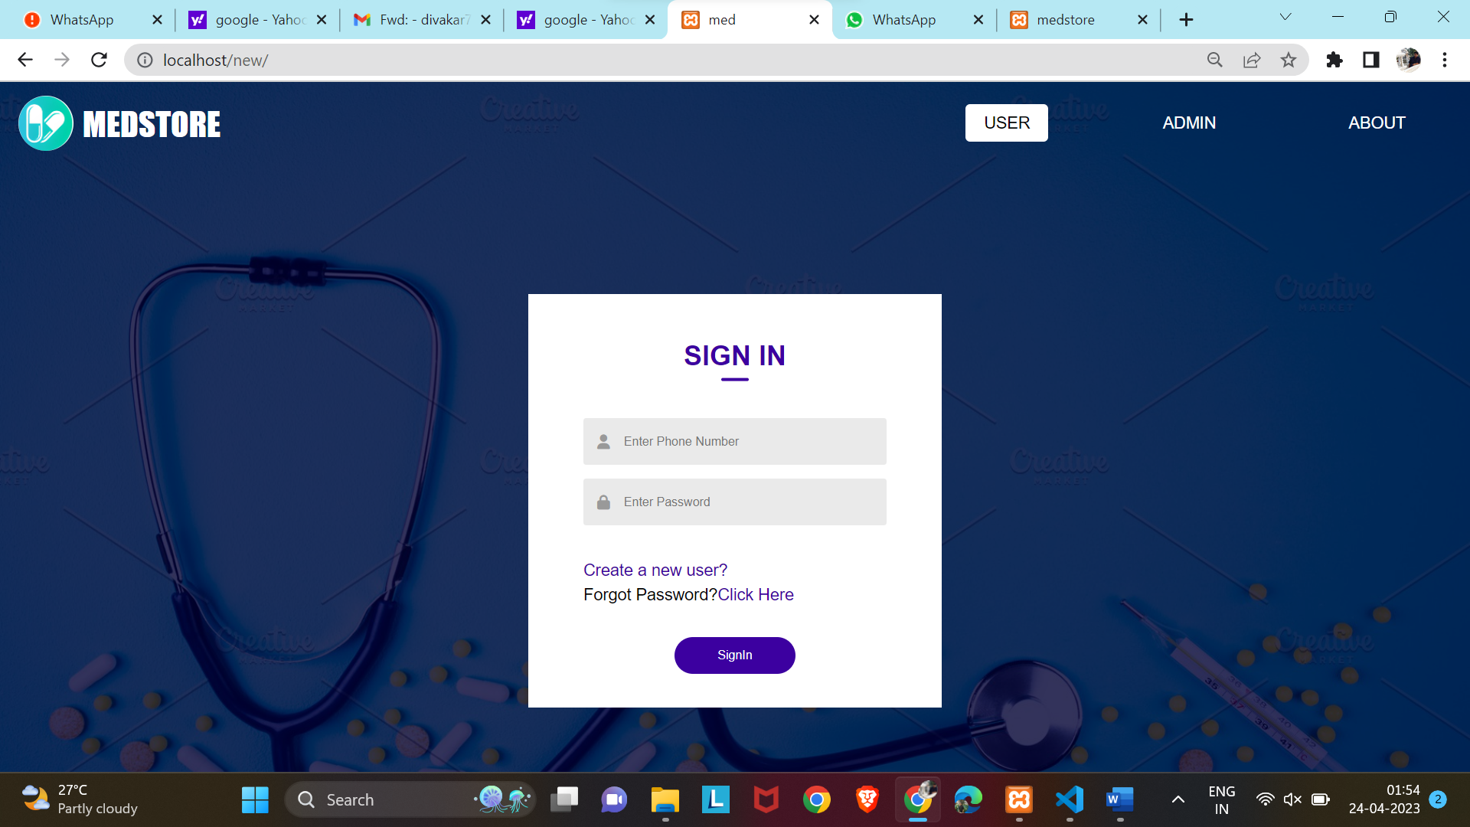

**2.User SignUp**

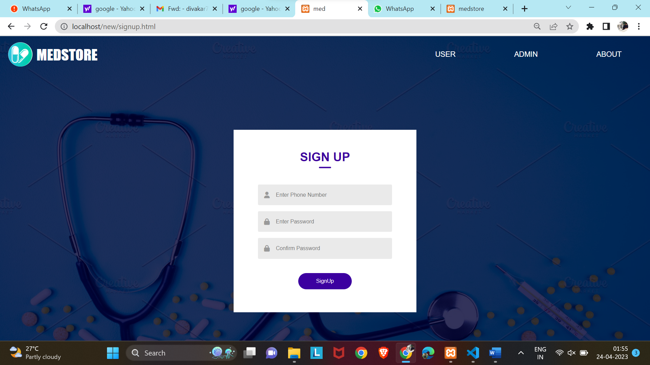

**3.Chage Password**

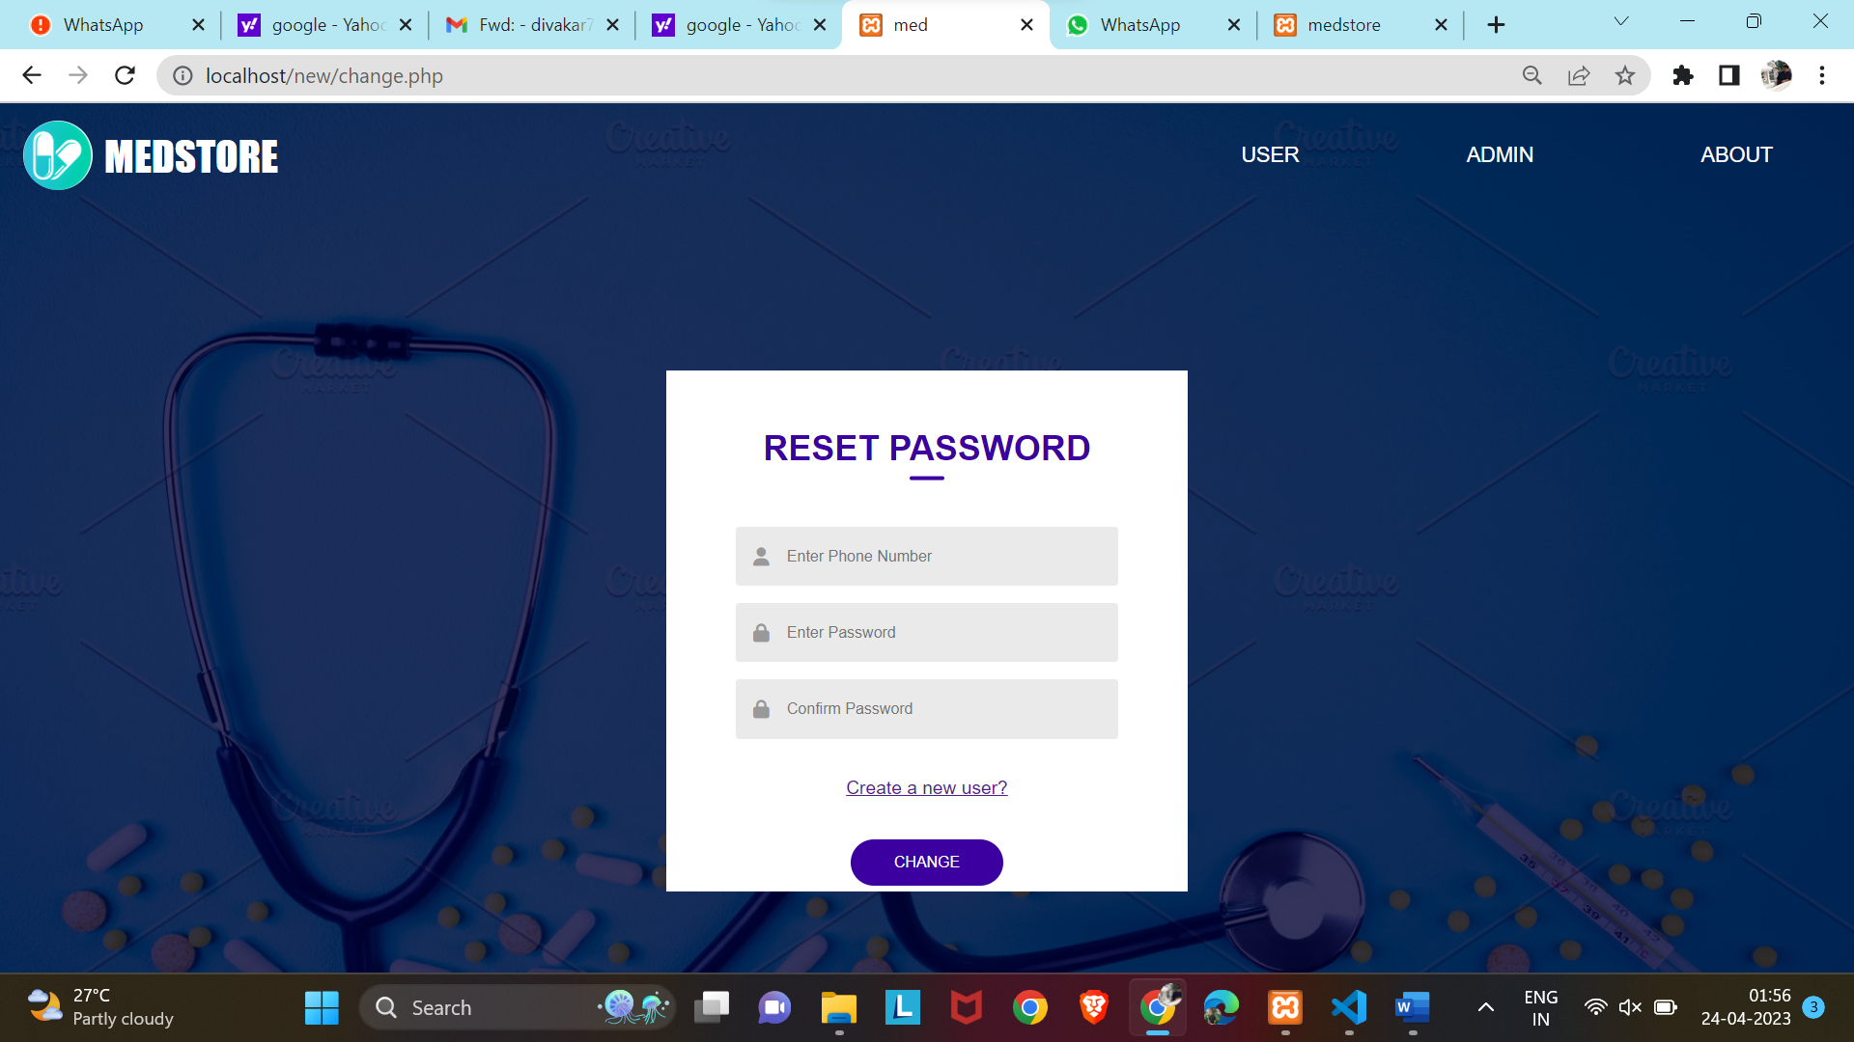

**4.Admin Sign In**

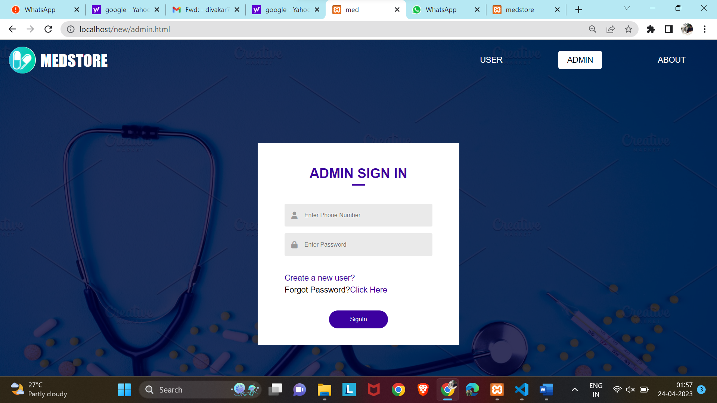

**5.Recent Page**

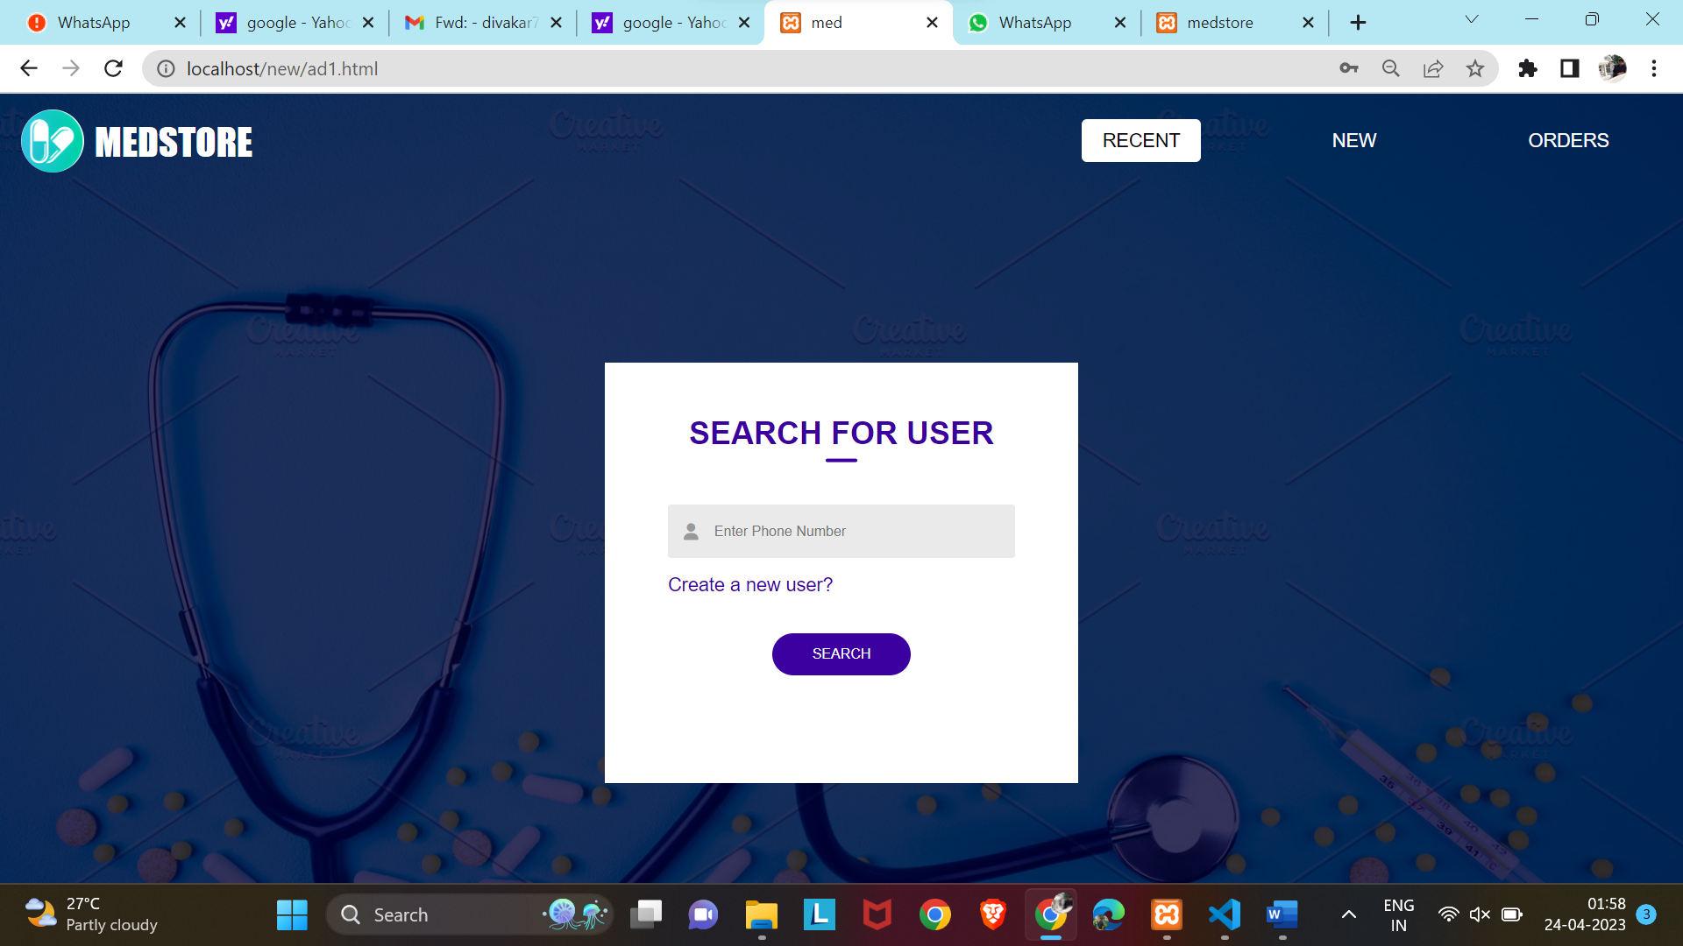

**6.Recent Page**

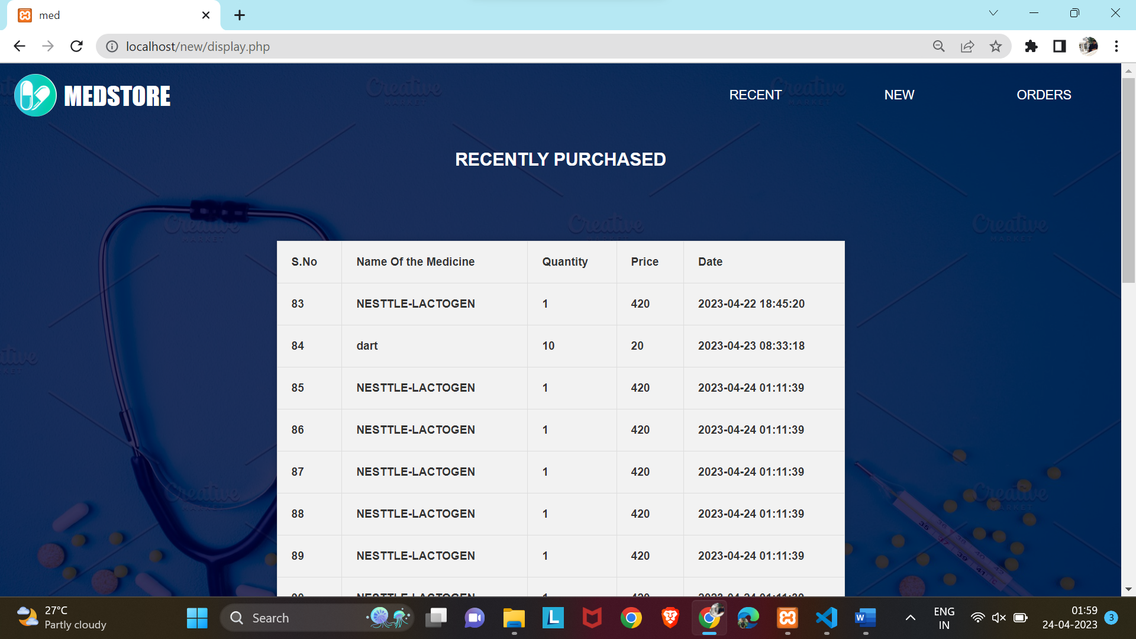

**7.New Medicines**

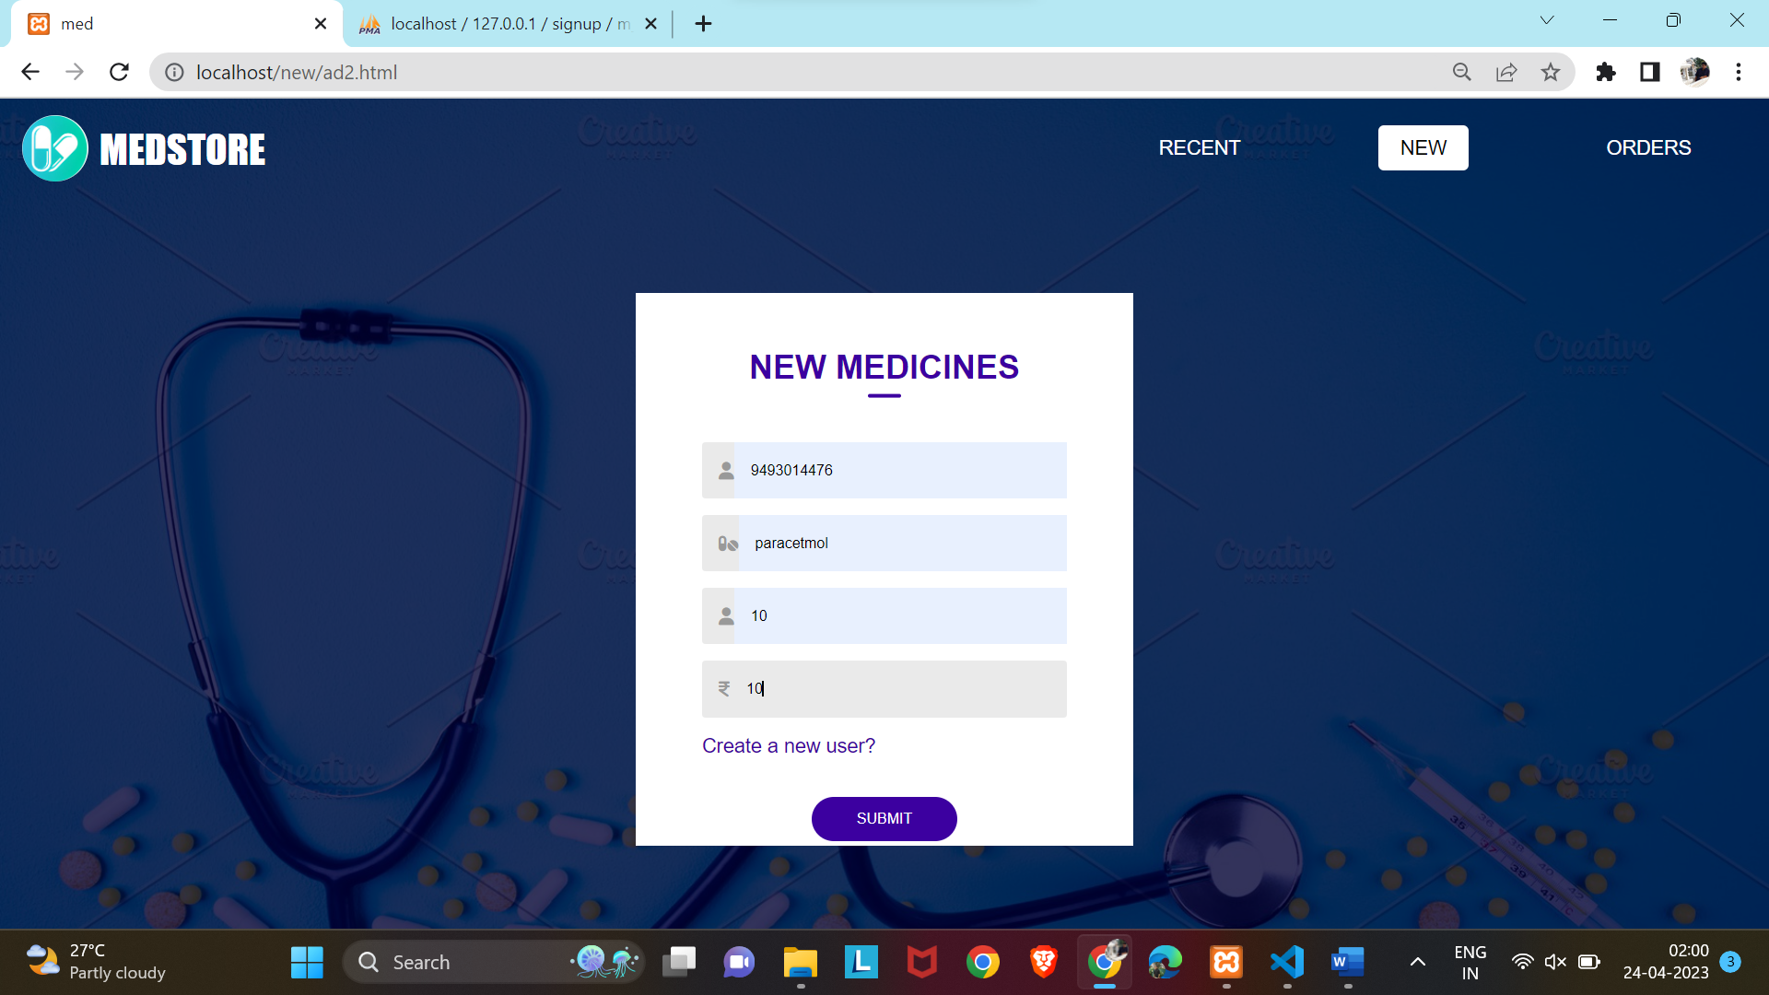

**8.Orders Page**

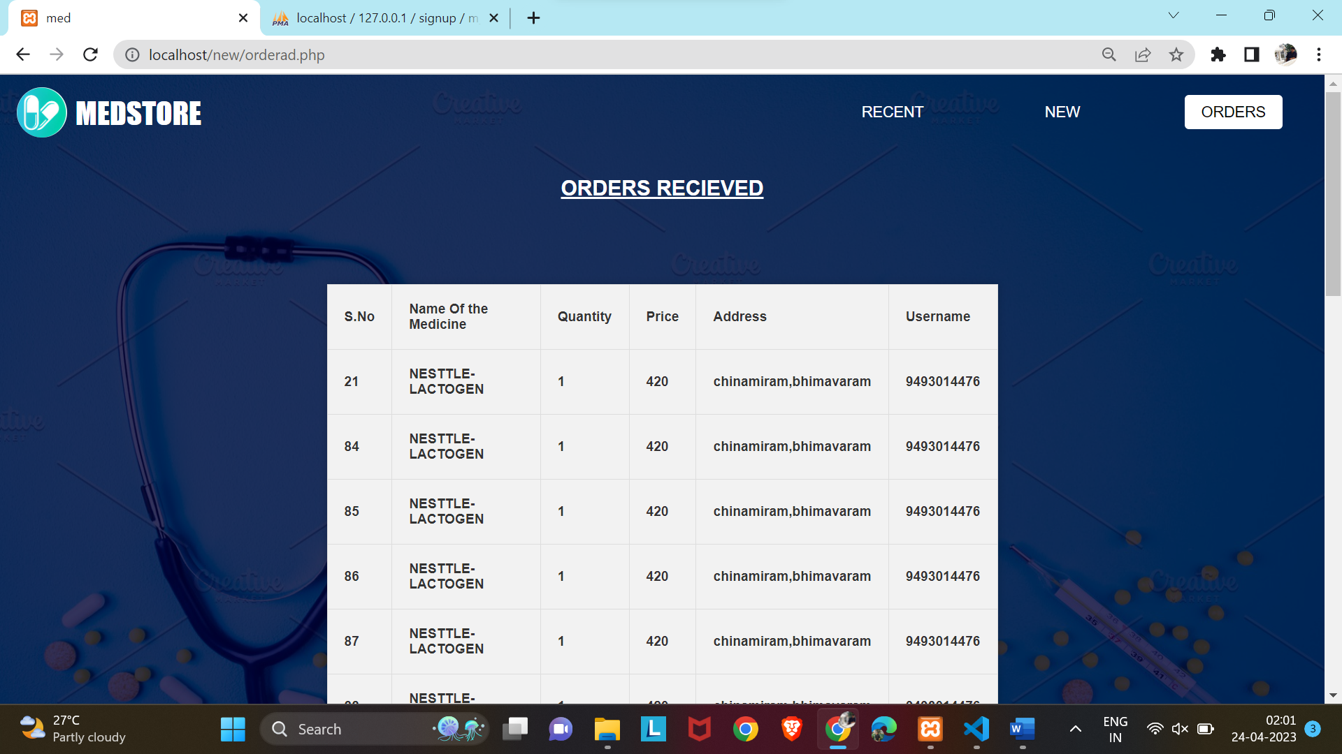

**9.Home Page**

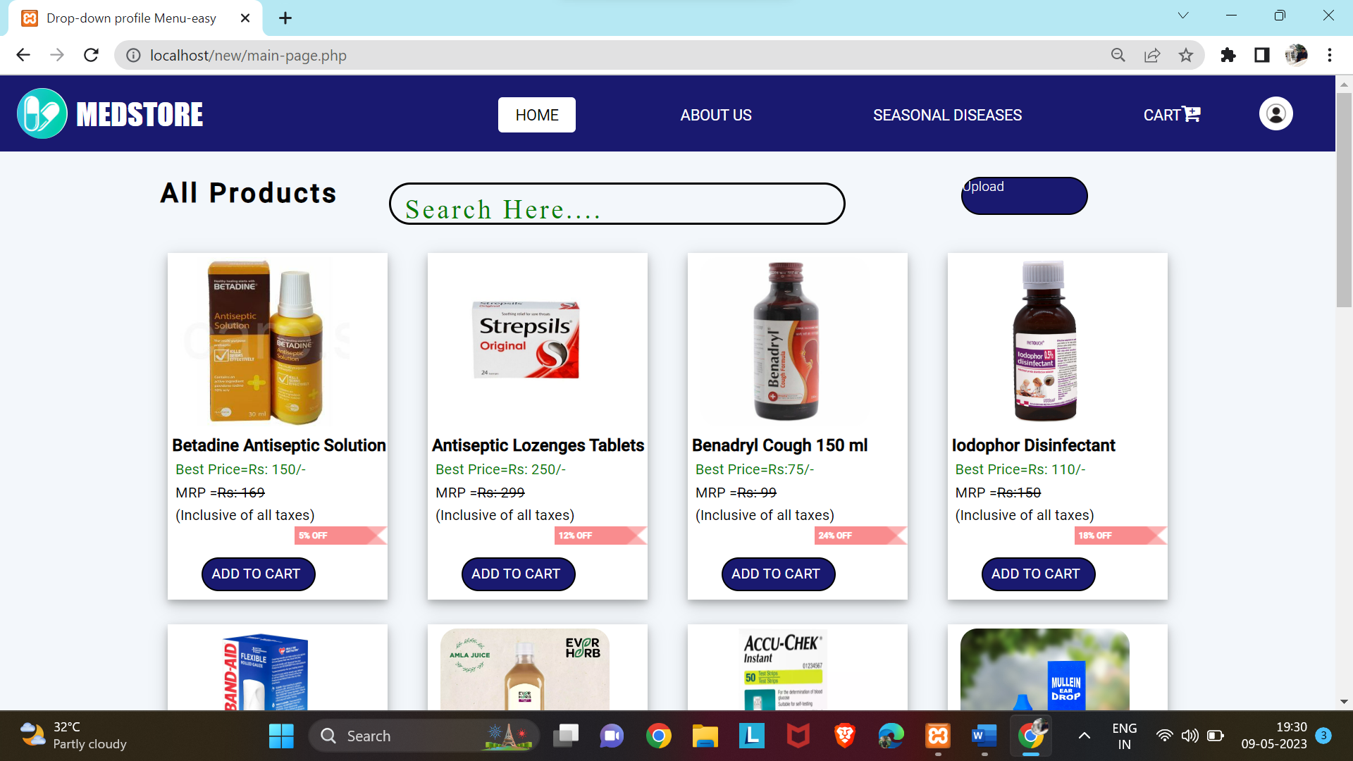

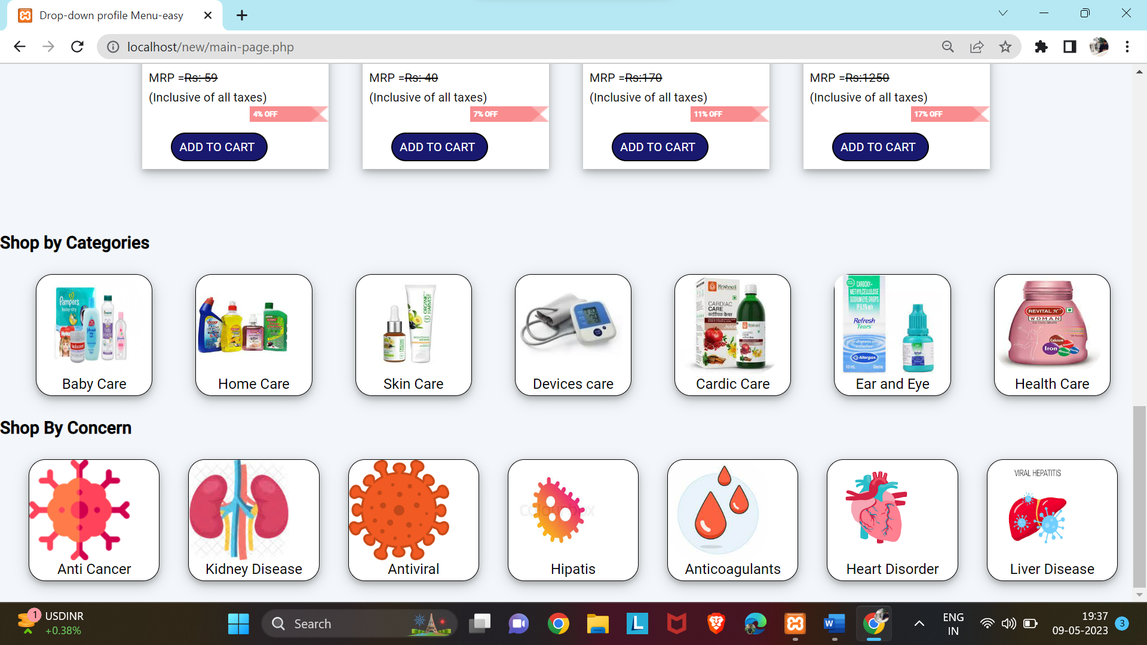

Home Care

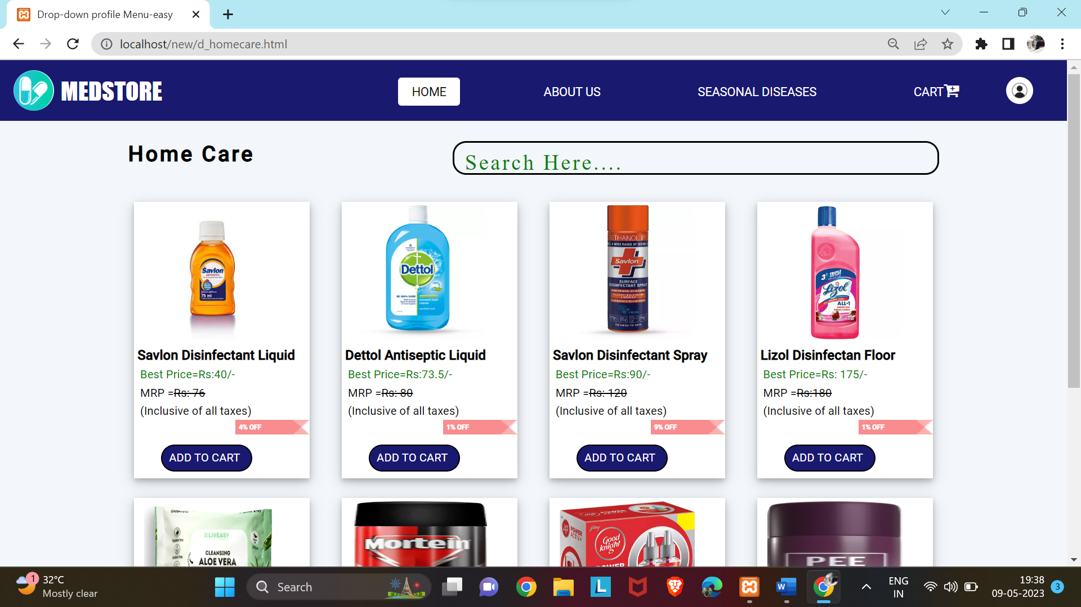

**10.Cart Page**

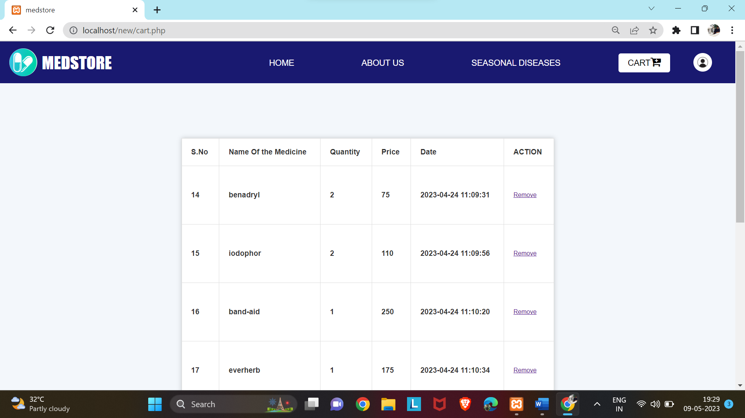

**11.Payment Page**

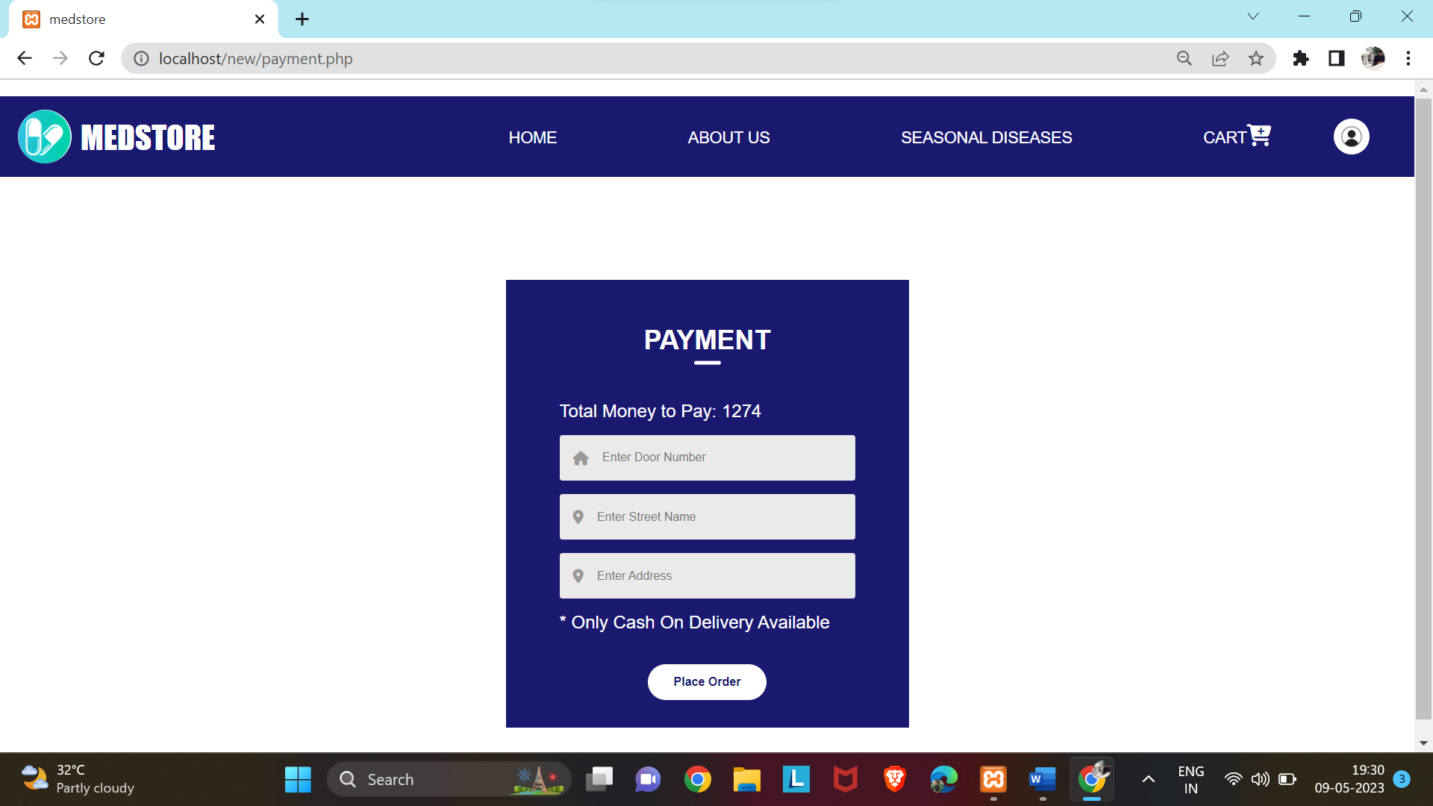

**12.Upload Page**

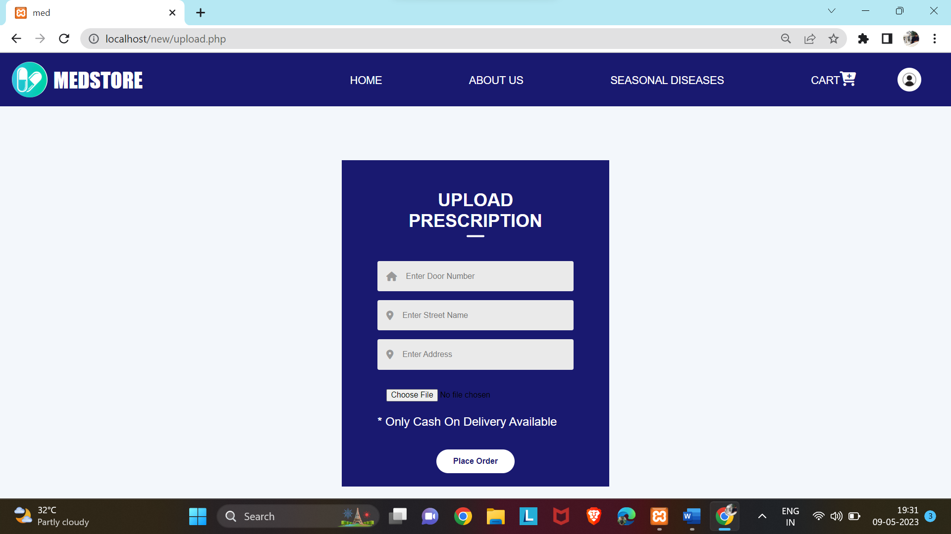

**13.About Page**

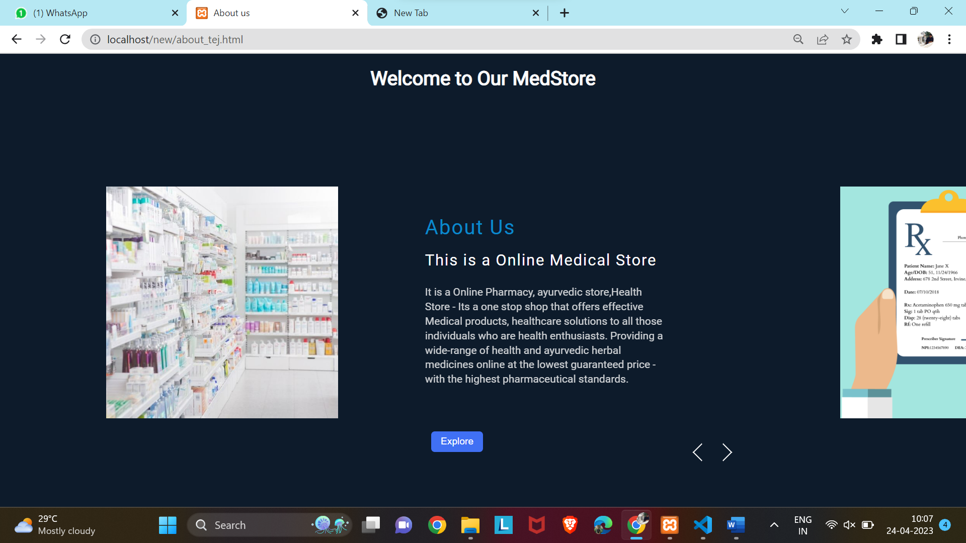

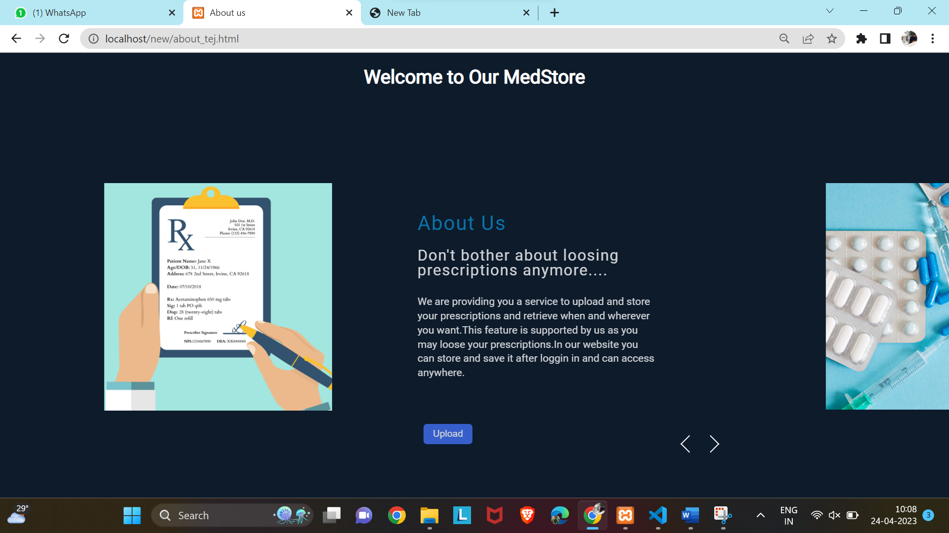

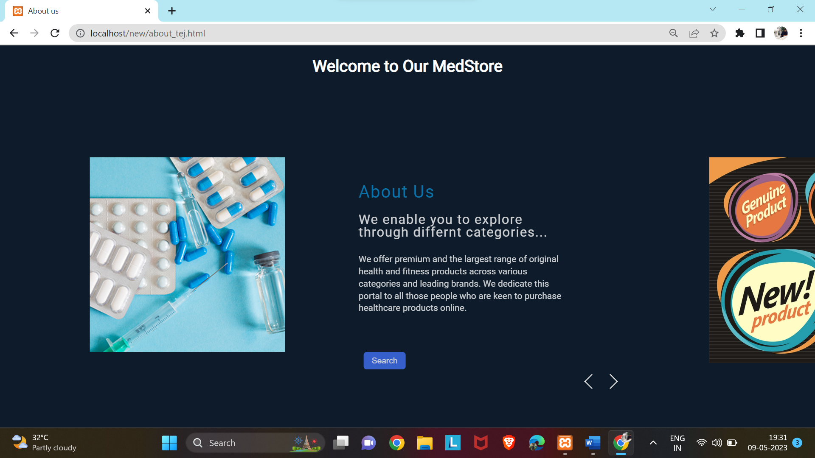

**14.Help and Support**

